Agricultural & Biological Engineering

West Lafayette, IN 47907

To: Dr. Abigail Engelberth

From: Kathryn Atherton

Date: March 30, 2018

Subject: Rheological Properties of Biological Fluids

Viscosity, or a fluid’s resistance to flow, is important to know to predict how a fluid behaves within a bioengineering process (Doran, 1995). Viscosity changes with the temperature of a system and, for non-Newtonian fluids, which are common among biological fluids, also changes with shear rate. Most biomaterials are shear thinning, meaning that as shear rate increases, viscosity decreases. Non-Newtonian fluid viscosity is described by a power-law model which uses rheological parameters k, flow consistency index, and n, flow behavior index, to do so (Doran, 1995).

A Brookfield digital viscometer was used to turn a spindle immersed in 200 mL of six different biological fluids for rotational speeds between 0.3 rpm to 100 rpm (Figure 1). The fluids tested were a solution of 85% glycerol, liquid yogurt, a solution of 35% cornstarch w/w in 85% glycerol, hair conditioner, fermentation broth with cells, and fermentation broth without cells. The viscometer measured the viscosity of the fluid as well as the percent power used to create the torque required to turn the spindle at the given rate (“3 Easy Steps”, n.d.). At least one trial of each fluid was performed, varying the shear rate in an increasing and then decreasing order for each trial.

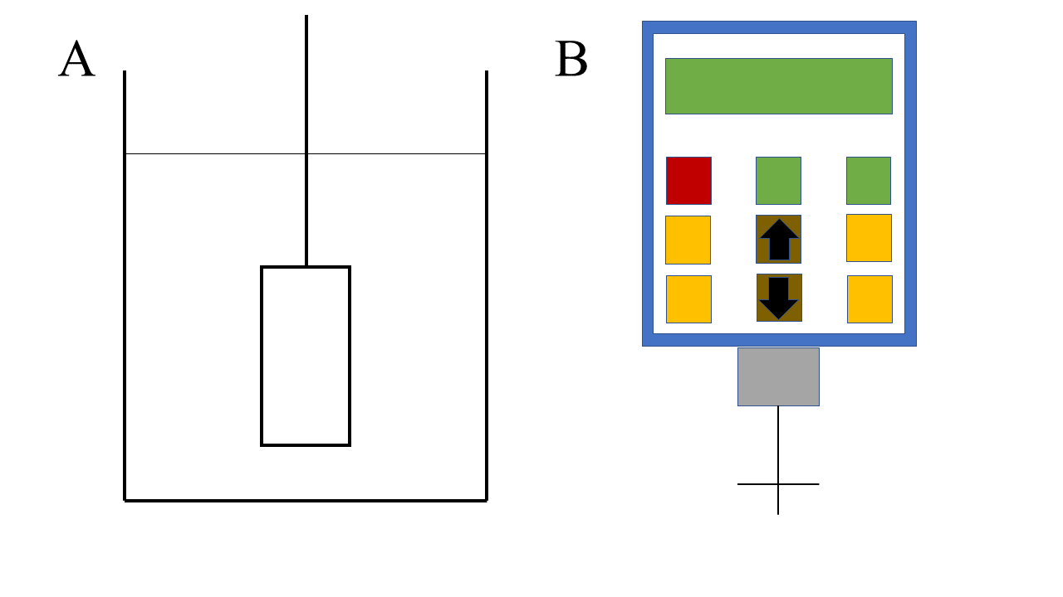

**Figure 1:** Schematic of Brookfield digital viscometer. Figure 1A shows how the spindle (model LV 1 pictured) was centered and immersed in the fluid. Figure 1B shows the user interface of the viscometer as well as a different model of spindle, a flat disk rather than a cylindrical shape (LV 3C). Different spindle models, LV 1, 2C, and 3C, were used for different types of fluids to ensure the most accurate viscosity measurement.

The data taken from the trials was converted into the necessary units and then the shear rate and viscosity data was used to calculate the shear stress for each fluid at each shear rate. Viscosity data and the shear stress values found from each trial were plotted against the shear rate. The viscosity vs. shear rate plots were used to determine whether the fluids tested are time-dependent, meaning that the viscosity of the fluid would be different when being measured as shear rate increases and decreases. The shear stress vs. shear rate plots were used to determine the type of fluid – shear thinning, or shear thickening – and the rheological constants k, the flow consistency index, and n, the flow behavior index, as well as the yield stress, if applicable to the fluid.

Three full trials were performed on the 85% glycerol solution and it was found that the viscometer could only produce accurate results for rotational speeds at or above 12 rpm. The viscosity vs. shear rate graph for this fluid showed that the fluid is time-independent (Figure 2). The shear stress vs. shear rate graph yielded trendlines that showed that the solution is a shear-thickening fluid (Figure 3).

Two trials were completed when testing the liquid yogurt. While increasing the shear rate, the viscometer got values for every shear rate tested, but the viscosity values became out of the range of acceptable accuracy once the rotational speed returned to 3 rpm during the decreasing phase of the trials. Graphing the viscosity vs. shear rate, it was found that the yogurt is a time-dependent fluid (Figure 4). The plot of shear stress vs. shear rate of the yogurt showed that the fluid is shear thinning with a yield stress of about 1 Pa (Figure 5).

One trial was completed for the testing of the 35% cornstarch w/w in 85% glycerol solution. During the increasing phase of the trial, results were yielded for rotational speeds between 4 rpm and 30 rpm, but while decreasing results were only yielded for rotational speeds between 5 rpm and 30 rpm. The plot of viscosity vs. shear rate showed that the fluid is time-dependent (Figure 6) and the graph of shear stress vs. shear rate showed that the cornstarch mixture is shear thickening (Figure 7).

Two trials completed for the hair conditioner testing yielded results for rotational speeds at or below 60 rpm. The plot of the viscosity against shear rate showed very little difference in behavior when measuring while increasing and decreasing the rotational speed, meaning that the conditioner is time-independent (Figure 8). Graphing the shear stress against the shear rate displayed a shear thinning trend and a yield stress of about 0.3 Pa was estimated from this graph (Figure 9).

The singular trial performed for the fermentation broth with cells yielded results for all tested rotational speeds. Graphing viscosity vs. shear rate showed that the fluid is time-independent (Figure 10). When plotting the shear stress against the shear rate, it was found that the fluid is shear thinning with an estimated yield stress of 1 Pa (Figure 11). The fermentation broth was also tested without the presence of cells and again, results were achieved for all tested rotational speeds, the viscosity vs. shear rate plot showed that the fluid is time-independent (Figure 12), and the shear stress vs. shear rate graph showed a shear thinning trend with a yield stress of about 1 Pa (Figure 13). While the two fluids are very similar, the fermentation broth with cells had a lower flow behavior index, meaning that the fluid becomes less viscous more rapidly than the fermentation broth without cells as the shear rate increases, which is opposite of what should theoretically occur (Newton, et. al., 2016). This may be due to errors in procedure such as not ensuring that the cells were homogeneously distributed throughout the broth or high shear rates causing the cells to lyse and allow less viscous fluid into the fermentation broth, making the overall viscosity lower.

Within the piping system used previously in the Pump Configuration and Flow through a Pipe lab, the shear thinning fluids—liquid yogurt, hair conditioner, and the two fermentation broths—would flow more quickly as the friction of the system increased while the shear thickening fluids—85% glycerol and 35% cornstarch w/w in 85% glycerol—would thicken up as the friction increased. It is recommended that for the most efficient flow, the shear thinning fluids be pumped at the highest possible flow rate while maintaining the integrity of the fluid to create more friction and minimize viscosity while the shear thickening fluids be pumped at the lowest possible flow rate for the system to minimize friction and thus viscosity.

Conclusions drawn from the Effect of Temperature and Agitation Speed in Mixing and Heat Transfer Systems lab show that for shear-thinning fluids, viscosity decreases with temperature and agitation speed increases and as viscosity decreases, mixing time also decreases. For the shear-thinning fluids—liquid yogurt, hair conditioner, and the fermentation broth with and without cells—it is recommended that to minimize mixing time to create homogeneous mixtures using each fluid, maximum temperatures and agitation speeds are used. However, as shear thickening fluids—85% glycerol and 35% cornstarch w/w in 85% glycerol—will become more viscous with increased agitation speeds, it is recommended that while the temperature should again be maximized, the agitation speed should be minimized to prevent the fluids from becoming too thick to properly mix.

**Appendix A: Figures**

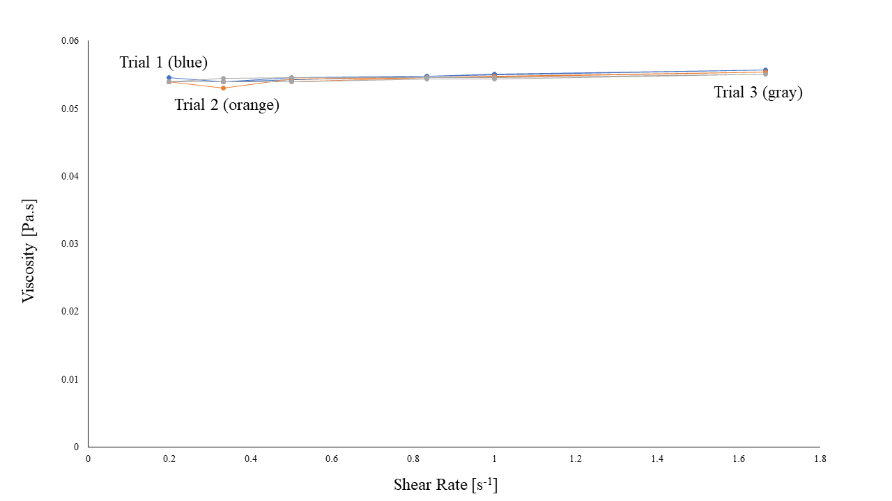

**Figure 2:** Plot of viscosity vs. shear rate for 85% glycerol solution. The graph shows that all three trials were nearly identical and there is no detectable difference between viscosity measurements taken when the shear rate was increasing and when the shear rate was decreasing. The consistency of measurements means that the 85% glycerol solution is a time-independent fluid.

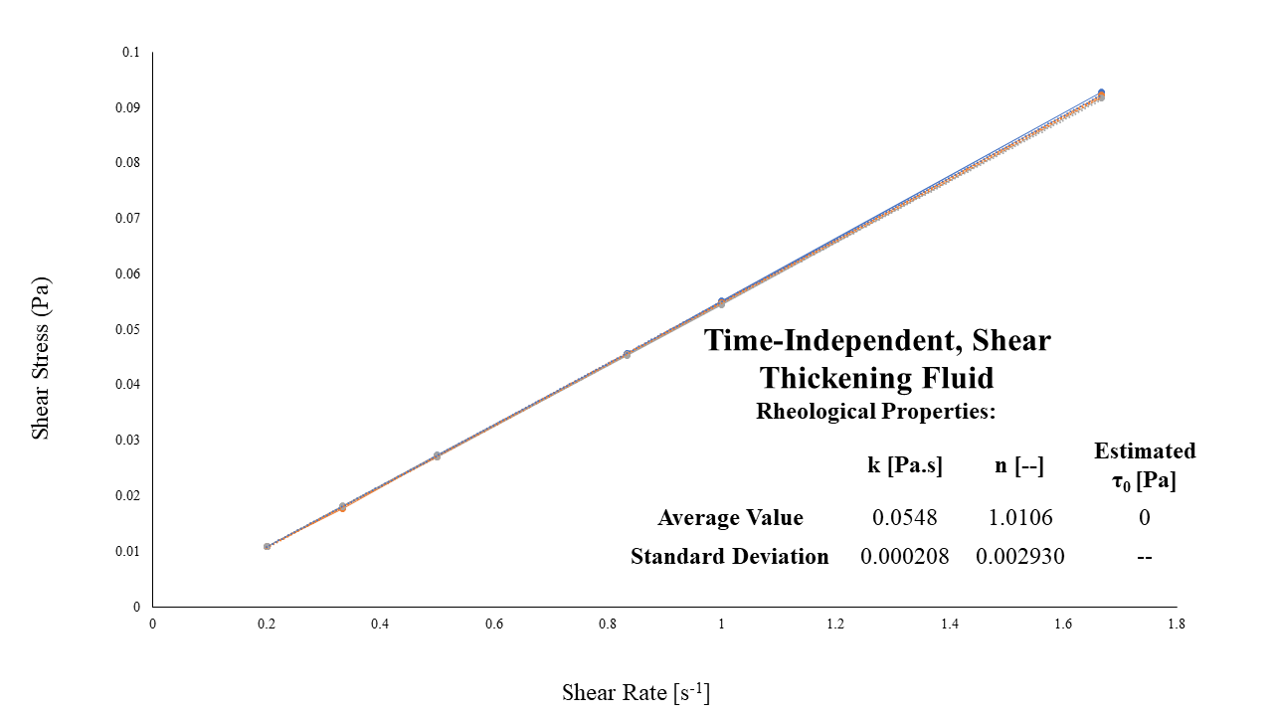

**Figure 3:** Plot of shear stress vs. shear rate for 85% glycerol solution. The data shows a nearly straight line, which would suggest that this is a Newtonian fluid, though the flow behavior index values were averaged from each trial’s trendline and found to be 1.0106, with a standard deviation of 0.002930; as the flow behavior index is greater than one, the solution is a shear-thickening fluid. The flow consistency index was found to be 0.0548 Pa.s with a standard deviation of 0.000208 and it is estimated there is no yield stress for this fluid.

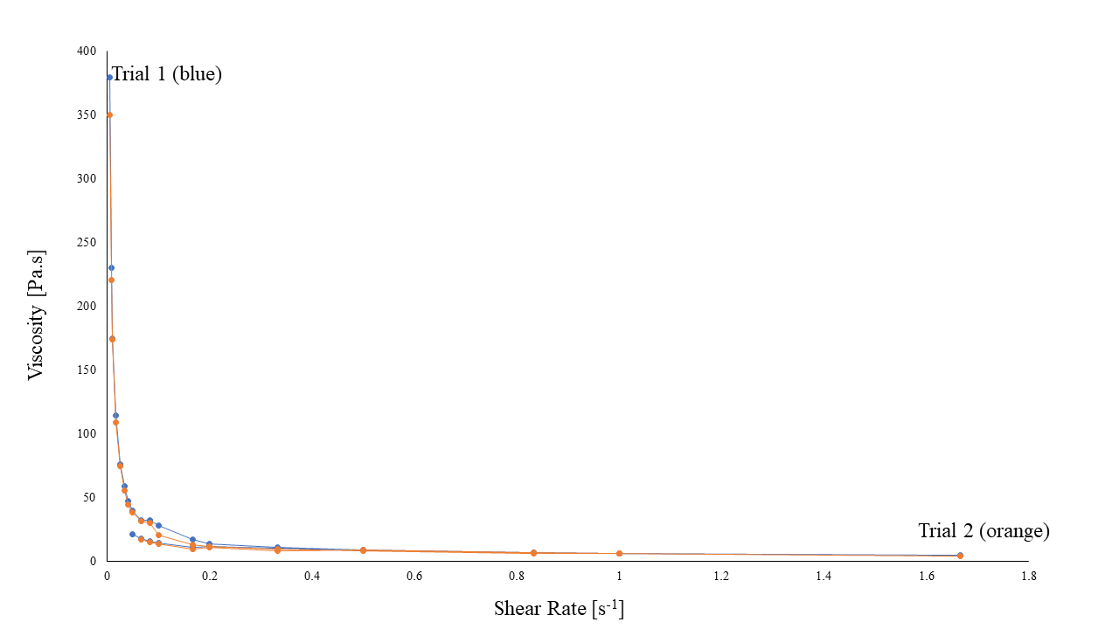

**Figure 4:** Graph of viscosity vs. shear rate for liquid yogurt. The graph shows for both trials, the viscosity measurements changed when decreasing the rotational speed. This observation coincides with the fact that while all rotational speeds yielded results from the viscometer while increasing the shear rate, the rotational speeds below 3 rpm did not yield results while decreasing the shear rate. The inconsistencies in behavior of the yogurt means that it is a time-dependent fluid.

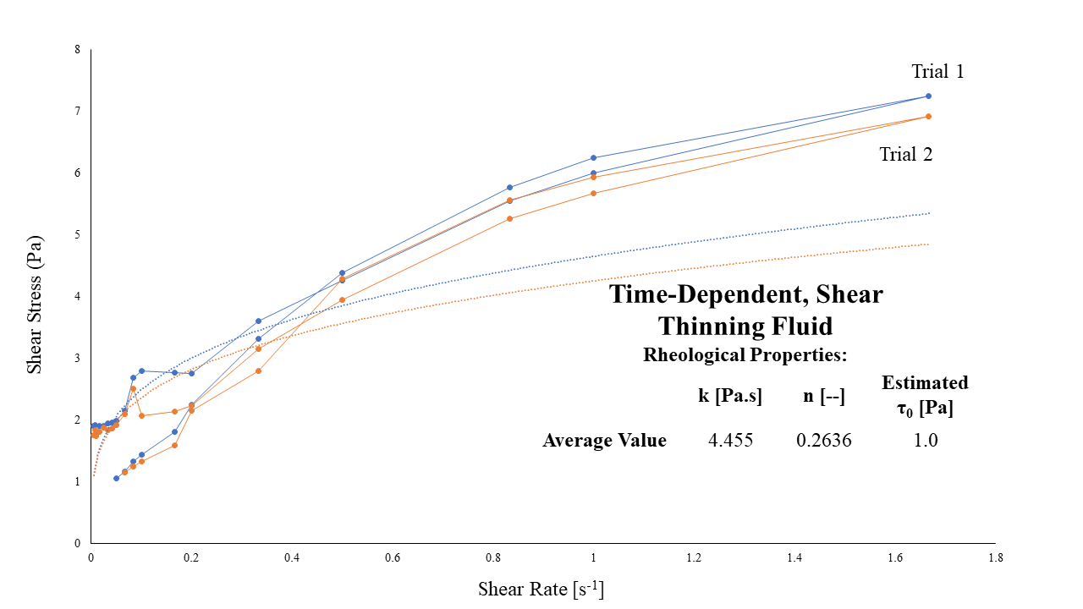

**Figure 5:** Plot of shear stress vs. shear rate for liquid yogurt. The data shows concave down curve with a y-intercept around 1 Pa, which is the estimated yield stress for the liquid yogurt. The flow behavior index values were averaged from both trial trendlines and found to be 0.2636; as the flow behavior index is less than one, the liquid yogurt is a shear-thinning fluid. The flow consistency index was found to be 4.455 Pa.s. Since only two trials were performed, standard deviations were not calculated for this fluid.

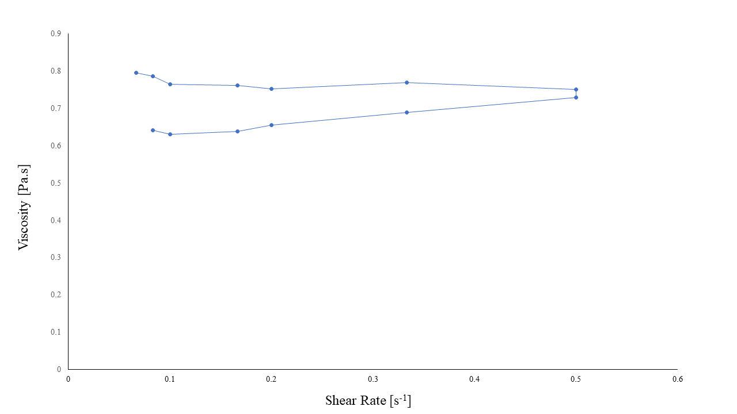

**Figure 6:** Plot of viscosity vs shear rate for 35% cornstarch w/w in 85% glycerol solution. The graph shows vastly different behavior for the solution when the shear rate was increasing vs when it was decreasing. The inconsistency of measurements means that the 35% cornstarch w/w in 85% glycerol solution is a time-dependent fluid.

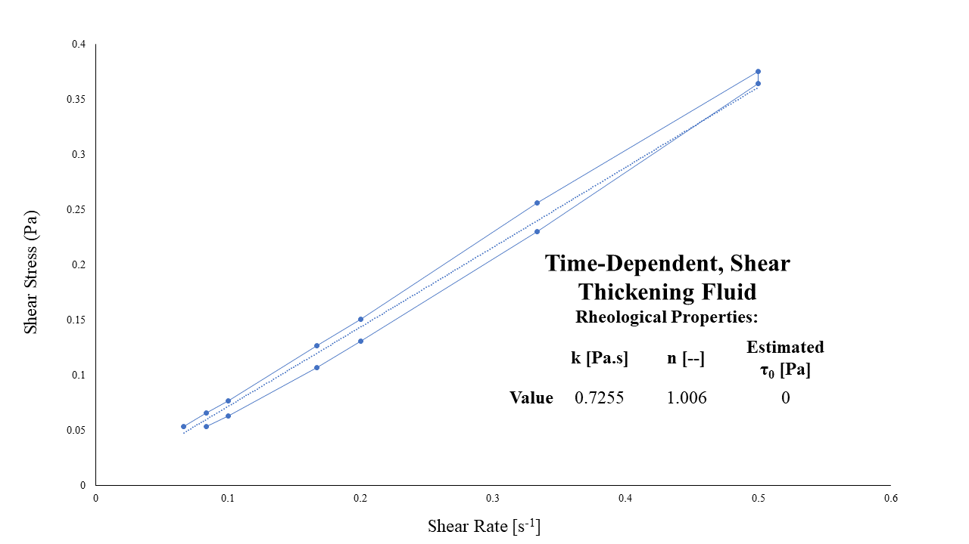

**Figure 7:** Graph of shear stress vs. shear rate for 35% cornstarch w/w in 85% glycerol solution. The data shows a concave up curve, and the flow behavior index value was found to be 1.006; as the flow behavior index is greater than one, the solution is a shear-thickening fluid. The flow consistency index was found to be 0.7255 Pa.s and it is estimated there is no yield stress for this fluid. As only one trial was performed on this fluid, no standard deviations could be calculated.

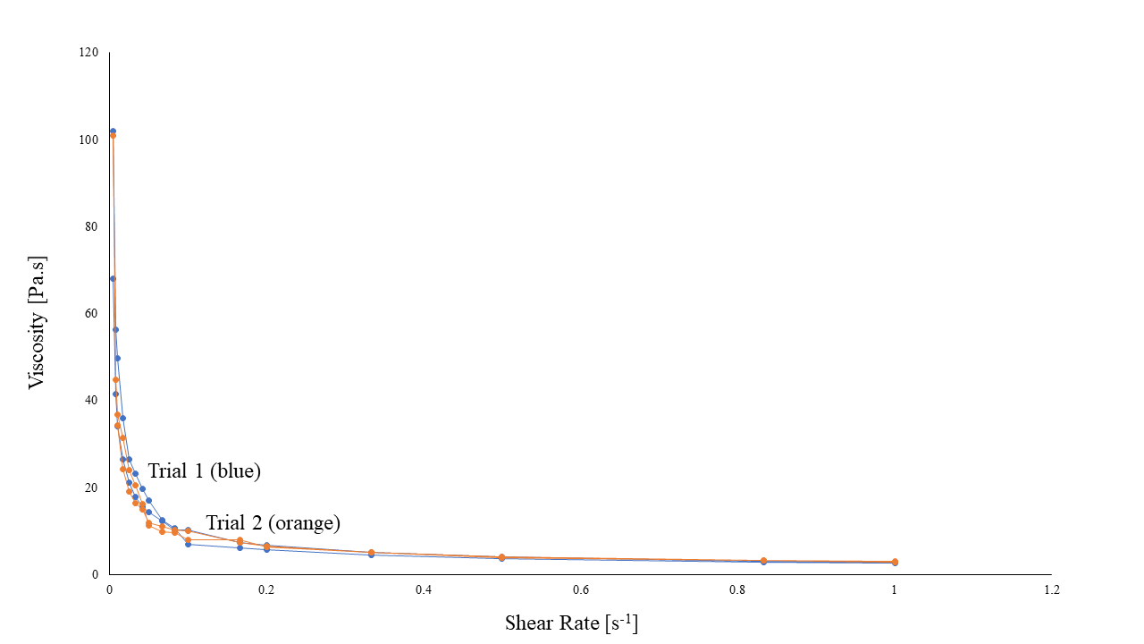

**Figure 8:** Viscosity vs. shear rate graph for hair conditioner. The graph shows that all both trials had almost no difference between viscosity measurements taken when the shear rate was increasing and when the shear rate was decreasing. The consistency of measurements means that the hair conditioner is a time-independent fluid.

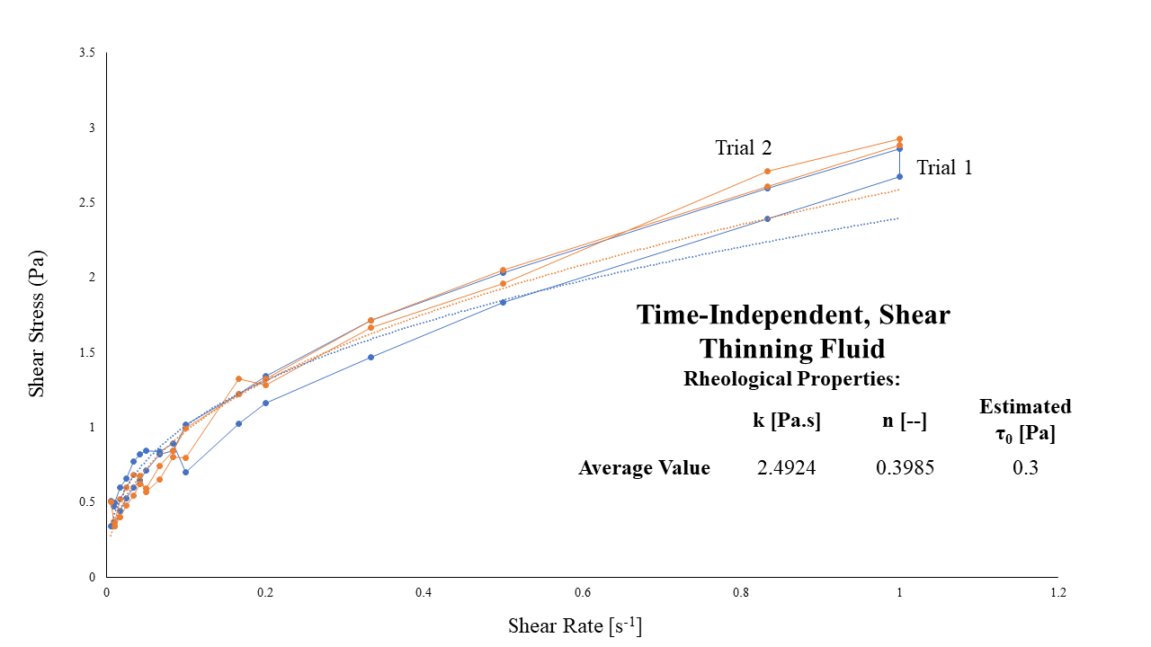

**Figure 9:** Shear stress vs. shear rate plot for hair conditioner. The data shows a concave down trend with an estimated y-intercept of 0.3 Pa, which represents the yield stress. The flow behavior index values averaged from each trial’s trendline was found to be 1.3985; as the flow behavior index is less than one, the solution is a shear-thinning fluid. The flow consistency index was found to be 2.4924 Pa.s. As only two trials were performed on this fluid, no standard deviations were calculated.

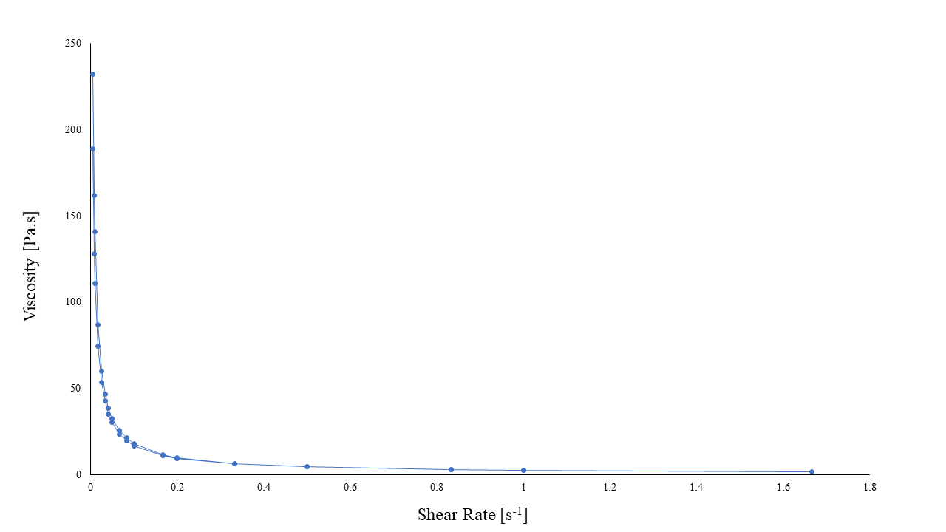

**Figure 10:** Graph of viscosity vs. shear rate for fermentation broth with cells. The graph shows that viscosity measurements taken when the shear rate was increasing and when the shear rate was decreasing are nearly identical. The consistency of measurements means that the fermentation broth with cells is a time-independent fluid.

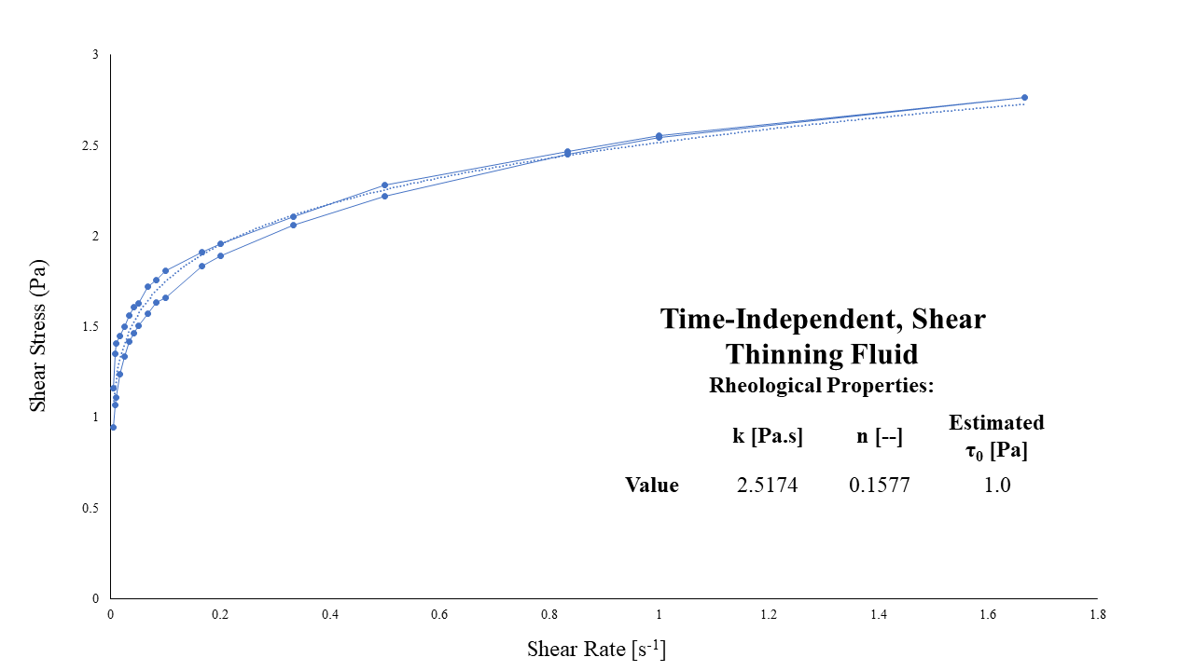

**Figure 11:** Plot of shear stress vs. shear rate for fermentation broth with cells. The data shows a concave down curve with a y-intercept of about 1 Pa, which represents the yield stress for the fluid. The flow behavior index was found to be 0.1577as the flow behavior index is less than one, the solution is a shear-thinning fluid. The flow consistency index was found to be 2.5174 Pa.s. As only one trial was completed for this fluid, no standard deviations could be calculated.

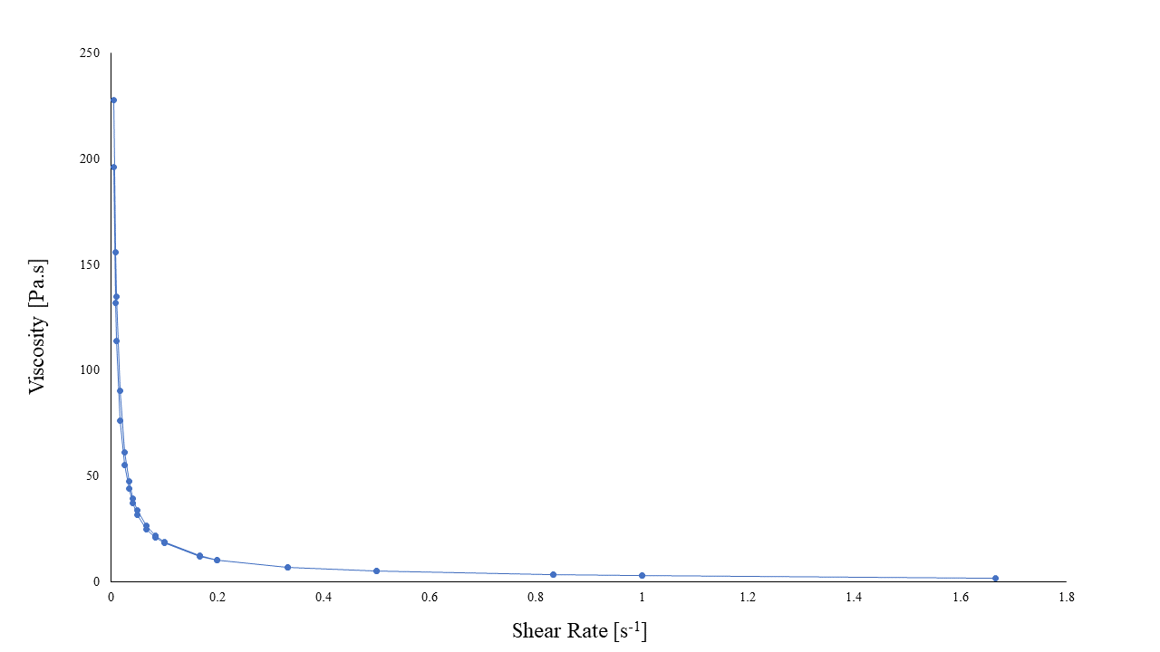

**Figure 12:** Graph of viscosity vs. shear rate for fermentation broth without cells. The graph shows that there is no detectable difference between viscosity measurements taken when the shear rate was increasing and when the shear rate was decreasing. The consistency of measurements means that the fermentation broth without cells is a time-independent fluid.

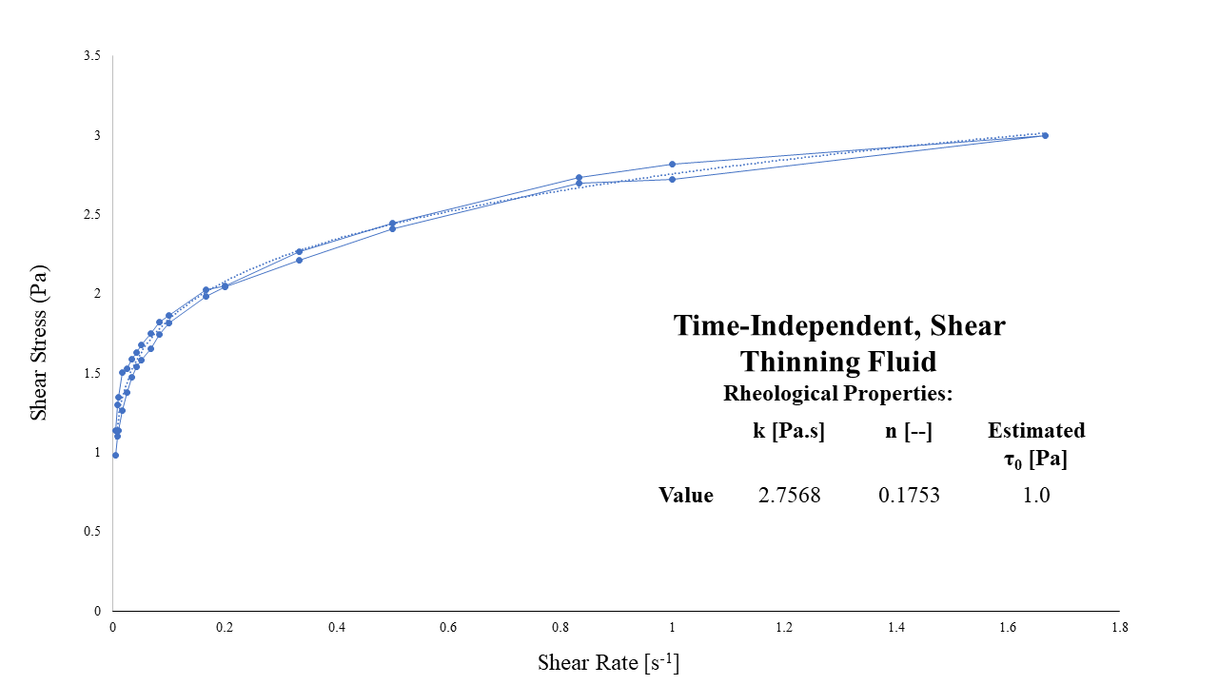

**Figure 13:** Plot of shear stress vs. shear rate for fermentation broth without cells. The data shows a concave down curve with a y-intercept of about 1 Pa, representing the yield stress for the fluid. The flow behavior index value was found to be 0.1753 as the flow behavior index is less than one, the solution is a shear-thinning fluid. The flow consistency index was found to be 2.7568 Pa.s. As only one trial was completed for this fluid, no standard deviations could be calculated.

**Appendix B: References**

Doran, P.M. (1995). *Bioprocess Engineering Principles*. London, UK. Academic Press Limited.

Newton, J.M., Schofield, D., Vlahopoulou, J., Zhou, Y. (2016). Detecting cell lysis using viscosity

monitoring in E. coli fermentation to prevent product loss. Biotechnology Progress.

3 Easy Steps to Successful Viscosity Measurement. (n.d.). Brookfield Ametek. Instrumentation &

Specialty Controls Division.